AUTONOMOUS DETECTION

AND ACTIVATION DEVICE

SERIES T-start

Models
T_{(45°)}-start
T_{(72°)}-start
T_{(110°)}-start
T_{(M)}-start

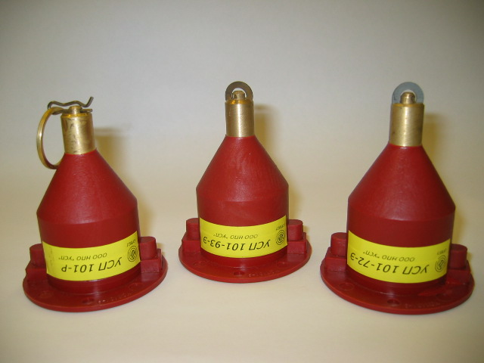

User Manual

Design, Operation & Installation Manual

CONTENTS

1. Introduction 3

2. General 3

3. Product Range 3

4. Operation 4

5. Design & Application 8

6. Technical Characteristics 11

7. Limitations 14

8. Installation & Wiring 15

9. Safety Requirements 16

10. Service Life & Maintenance 17

11. Packaging 18

12. Disclaimer 18

13. Warranty 19

1. INTRODUCTION

This document represents a user manual and provides technical information on design, operation and maintenance of T-start devices. It also includes warranty.

2. GENERAL

T-start is a unique autonomous thermal activation and detection device that allows detecting a fire and activating a powder, aerosol or gaseous fire suppression system. Also the device has features such as provision of a signal to a fire panel and incorporation of an additional output designed to shut down the electrical equipment or activate an alarm (depends on a specific modification).

T-start can also be used as a thermal detector with a fixed temperature reading and can be connected to an existing fire detection circuit or a fire-indicating panel.

T_{(HZ)}-start is a special design version of T-start containing an intrinsically safe interface and designed for use in hazardous areas.

3. PRODUCT RANGE

The T-start comes in four different models. Three models operate automatically, similar to the thermal detectors with rated temperatures. The fourth model is designed for manual operation.

The models are as follows:

- Model T_{(45°)}-start (suitable for cold areas)
- Model T_{(72°)}-start (standard applications)
- Model T_{(110°)}-start (suitable for motor rooms and tracks)
- Model T_{(M)}-start (manual operation)

All models could be accomplished in all design versions – for use in harsh environments, in detection circuit or/and in hazardous areas.

4. OPERATION

4.1 General

No external power supply is required for operation of the T-start device.

T-start device comes in two basic types, for automatic and manual operation.

4.2 Automatic Operation

A schematic of T-start for automatic operation is shown in Figure 1.

The main feature of the automatically operated T-start is a special heat-sensitive element (7) with a rated temperature reading. When subjected to a fire or a heat the element expands at the rated temperature reading and releases a spring-loaded rod (10) mounted inside a nosepiece (9).
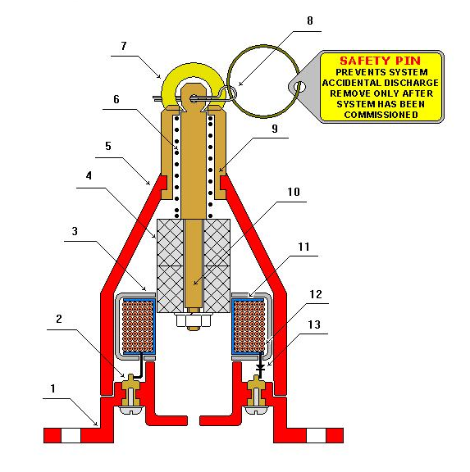
Figure 1. Schematic of T-start (automatic operation)

1. Base
2. Electric terminals
3. RF & EMI shielded protective cover
4. Magnet
5. Housing made from a high-temperature plastic
6. Compression spring
7. Heat sensitive element made from a shape memory alloy
8. Safety pin
9. Bronze nose piece
10. Bronze rod
11. Frame of reel
12. Electromagnetic coil
13. Diode

The spring moves a cylindrical shape magnet (4), which is mounted on the rod (10), through an induction coil (12). The induction coil generates an electric impulse. The impulse is transmitted to the electrical terminals (2) and further to the aerosol or powder fire extinguishers.

4.3 Manual Operation

A schematic of T_{(M)}-start for manual operation is shown in Figure 2.

In the manually operated T-start a special ring (5) is used instead of the heat-sensitive element used in automatically operated models.

In case of fire a split pin (6) is removed from the device by manually pulling the ring (5). This action releases a spring-loaded pin (9). Further sequence of events is identical to that for automatically operated T-start.
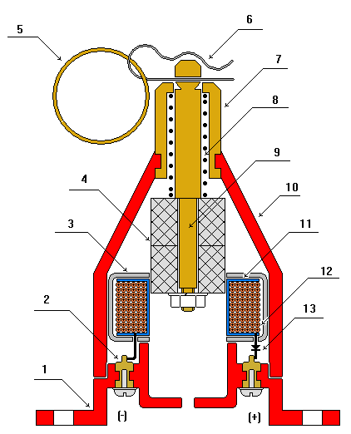
Figure 2. Schematic of T_{(M)}-start (manual operation)

1. Base
2. Electric terminals
3. RF & EMI shielded protective cover
4. Magnet
5. Pull ring
6. Split pin
7. Bronze nose piece
8. Compression spring
9. Bronze rod
10. Housing made from a high-temperature plastic
11. Frame of reel
12. Electromagnetic coil
13. Diode

5. APPLICATION & DESIGN

Depending on the intended use T-start device comes in three various design versions.

5.1 Use in harsh environments

For applications in harsh environments the T-start can be installed with a special protective cup as shown in Figure 3.

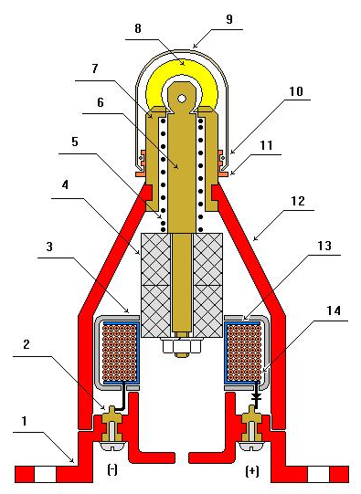
Figure 3. Schematic of T-start with a protective cup

1. Base
2. Electric terminals
3. RF & EMI shielded protective cover
4. Magnet
5. Compression spring
6. Bronze rod
7. Bronze nose piece
8. Heat sensitive lock made from a shape memory alloy
9. Protective cup
10. “O” Ring
11. Bushing
12. Housing made from a high-temperature plastic
13. Frame of reel
14. Electromagnetic coil

The protective cup shields the T-start device from possible mechanical and environmental impacts, however, the cup reduces the sensitivity of the heat-sensitive element in the automatically operated T-start devices and as a result increases their activation time.

5.2 Use in detection circuit

In most applications apart from its use as an activation device T-start is also used as a thermal detector. In such applications the device is connected to an existing fire detection line or directly to a fire panel via a specially designed junction box. A schematic of T-start with such junction box for use in detection circuit is shown in Figure 4.

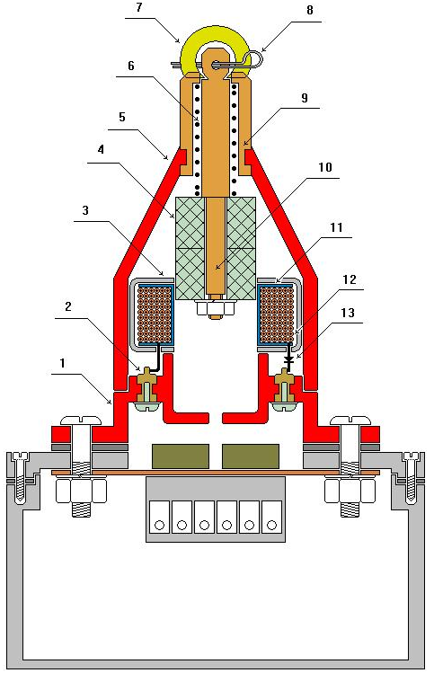

Figure 4. A schematic of T-start with a detection circuit junction box

A wiring diagram of T-start connection to a detection circuit is shown in Figure 5.

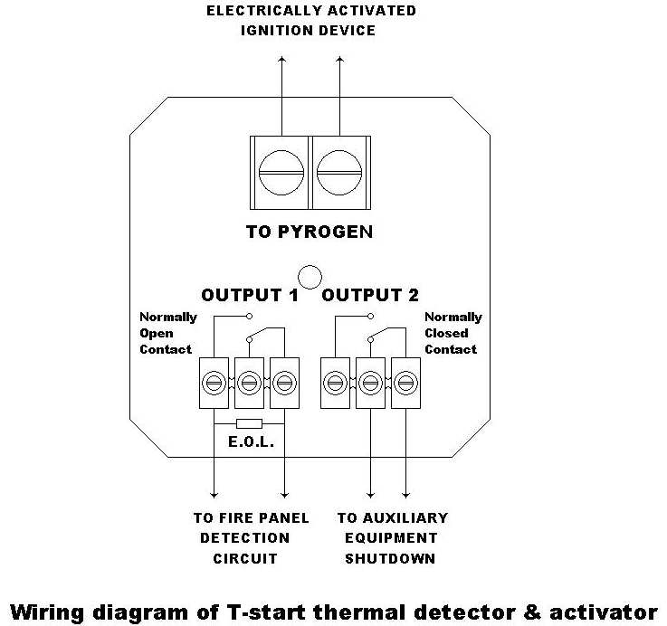

Figure 5. Wiring diagram of T-start connection to a detection circuit

5.3 Use in hazardous areas

T_{(HZ)}-start is a special design version of T-start containing an intrinsically safe interface and designed for use in hazardous areas.

6.TECHNICAL CHARACTRISTICS

6.1 Dimensions and Mass (protective cup and junction box excluded)

- Length, mm – not more than 85mm;
- Diameter, mm – not more than 65mm;
- Total mass, kg – not more than 0.2

6.2 Operation Temperature Ranges

- T_{(45°)}-start from –60 to +30ºC;
- T_{(72°)}-start from –60 to +55ºC;
- T_{(110°)}-start from –60 to +95ºC;
- T_{(M)}-start from –60 to +95ºC

6.3 Rated Activation Temperature

- T_{(45°)}-start +45ºC±5ºC
- T_{(72°)}-start +72ºC±5ºC
- T_{(110°)}-start +110ºC±5ºC

6.4 Activation Time

Activation time depends on the model of T-start, initial ambient temperature and the temperature increase rate.

The temperature increase rates (TIR) of 3ºC/min and 30ºC/min have been selected as standard. For TIR 30ºC/min activation time should be in the range of 58 – 144 seconds and for TIR 3ºC/min - in the range of 580 –960 seconds.

Test results on the T_{(72°)}-start and T_{(110°)}-start activation times are showed in the Table 1.

 |  | TIR 30ºC/min |  | TIR 3ºC/min
T_{(xx°)}-start Model | Initial Ambient  Air Temp. (ºC) | Maximum Time Delay, s | Minimum Time delay, s | Maximum Time Delay, s | Minimum Time Delay s
T_{(72°)}-start | 35 | 93 | 85 | 740 | 724
T_{(110°)}-start | 70 | 137 | 125 | 950 | 937

Table 1. Activation times for T_{(72°)}-start and T_{(110°)}-start

6.5 Electrical parameters

An electrical diagram of the device is showed in Figure 6.
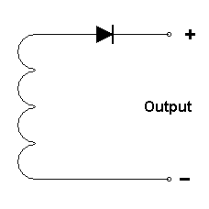 Figure 6. Electrical diagram for T-start

The device generates an electric impulse with amplitude of 3.5V DC at the circuit resistance of 1.0 Ohm.

The duration of the electric impulse is not less than 1 millisecond for the amplitude of not less than 3.0V DC.

The device can activate the following types of electrical initiators: MB-2H, 3A-1, PP-9, YGP-10, and similar.

7. LIMITATIONS

The design and application limitations for T-start devices are as follows.

1. Volume protected by one device shall not exceed 18m³.

2. The dimensions of a protected area shall not exceed:

Height - 3.0 meters
Width - 2.4 meters
Length - 2.5 meters

- The device should be located in the middle of the protected area at 100-150 mm below the ceiling.

- The device is capable of sustaining vibration from 0.5 to 200 Hertz with acceleration of 4g.

- The device is capable of sustaining impacts of up to 4g-force of 2 to 50 milliseconds duration.

- The device is suitable for application in hazardous areas of 2ExeIIT6 category .

- The T_{(HZ)}–start device is an intrinsically safe device and suitable for use in hazardous areas of POExiaI category.

- Maximum relative humidity – 98% (no condensation).

8. INSTALLATION & WIRING

The installation and wiring requirements for T-start devices areas follows.

- One circuit shall have not more than 10 devices.

- The length of the cable between two devices in a loop shall not exceed 3 meters.

- The devices shall be connected in parallel. Normal polarity of “+” to “+” shall be observed.

- The device can be used in high density electromagnetic and high frequency energy zones.

- Activation cables shall be fire-resistant with copper conductors. A cross-section area of each conductor should not be less than 1 mm² or 0.5 mm² for a multiple core cable.

- If run through a high frequency energy zone, such as a two-way radio, a sonar etc, the cable should be screened.

- If run through the electric magnetic fields of high density, such as high voltage transformers in power substations or cable tunnels, the cable should be enclosed in a steel conduit.

- Cable screen and steel conduit shall be grounded in accordance with the standard requirements.

- If there is a likelihood of any mechanical damage the cable should be enclosed into a plastic or metal conduit.

9. SAFETY REQUIREMENTS

The safety requirements for the T-start device are as follows.

- The device shall be installed and maintained in accordance with its design requirements and technical specifications.

- Only authorized personnel can install, re-set and service the device.

- The device shall only be used as intended - for detection of fire and activation of a fire suppression system.

- The attached safety pin shall be in its place during any installation, maintenance or service work conducted within the protected area to prevent an accidental discharge of the fire suppression system.

- The heat-sensitive element shall be firmly fixed in its position in the device.

- All screws on electrical terminals shall have spring washers.

- In case T-start does not incorporate the junction box for use in the detection circuit it should be attached to another appropriate junction box to ensure proper cable connections.

- The device is incapable of generating the electric impulses at levels dangerous for humans or animals.

- The connecting of the cable to the fire suppression units shall always be the last wiring procedure.

- After the system has been commissioned remove the safety pin (if required a protective copper cup could be installed after removal of the safety pin) to ensure the system is left in operable condition. Before removing the pin ensure the heat-sensitive element is firmly attached to the bronze rod inside the device.

- Where the protective copper cup is installed bend the edge of the cup into the bushing in two opposite points in order to avoid its accidental removal.

10. SERVICE LIFE & MAINTENANCE

- The T-start device is maintenance free. The reliability of the device is not less than 50,000 hours under normal ambient conditions. The service life of the device is 10 years.

- If damaged or exposed to the fire the device shall not be re-used.

- Should the heat-sensitive element be damaged, the device shall not be used.

- Should the device be set off by an accident it shall be returned back to the supplier or the manufacturer. It shall not be re-used as the heat-sensitive element might have been damaged or overheated.

11. PACKAGING

- The devices are placed in a cardboard box. There are 10 devices per box.

- Inside the box the devices are placed in rows with a carton packaging material filling the space between the devices.

- A packaging list, a user guide and manual are enclosed in a plastic envelope and placed onto the top row (one envelope per every ten devices).

- The following labels shall be attached to each cardboard box:

- Fragile
- Keep in dry place
- Do not drop
- Delicate equipment

12. DISCLAIMER

This manual is for use by trained and authorized personnel only. Unauthorized copying of this manual and its contents and use by unauthorized personnel is strictly forbidden and may lead to legal actions against those who do so. The document is accurate at time of issue, however, is subject to changes to its content from time to time.

13. WARRANTY

The manufacture claims that T-start have undergone a quality control and have no defects. Warranty applies for one year from the date of purchase.

This limited warranty does not cover any T-start device that has been damaged or rendered defective as a result of an accident, misuse or abuse, or serviced by anyone other than authorized service person, or by using the parts that are not manufactured or sold specifically for this device, or any modification done without written permission of the manufacturer.

Manufactured by

Artek Engineering Pty Ltd

47 French Street, Maroubra NSW 2035 Australia
ABN 55 102 571 095
Fax: +(61 2) 9344 0275
Technical support: +61 (0) 408 026 162

Email: serge@artek.net.au
Email administration@artek.net.au
Web http://www.artek.net.au/





